
Shri Sant Gajanan Maharaj College of Engineering, Shegaon
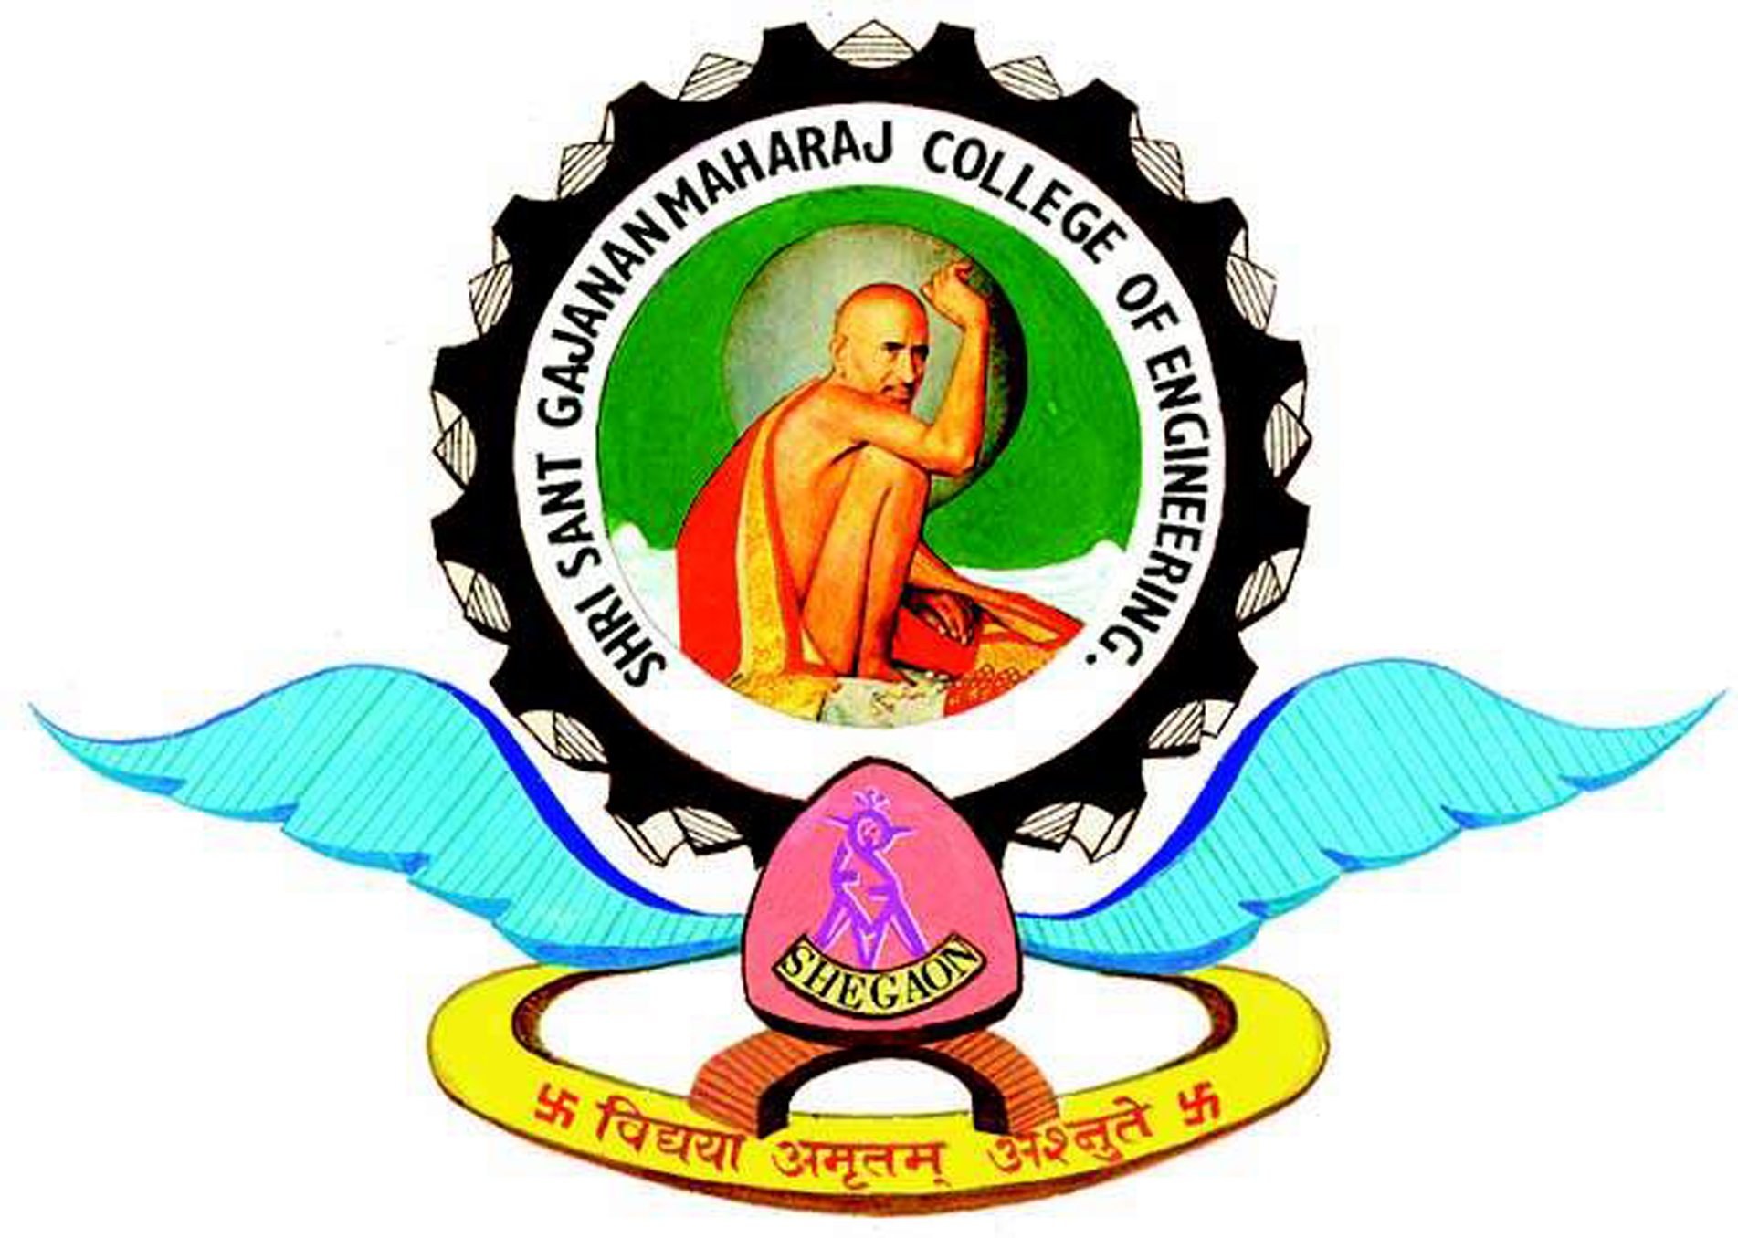
DEPARTMENT OF ELECTRONICS & TELECOMUNICATION

Electronics Student & Staff Association
(ESSA)
Session : 2019-20
Post | Member Name
Chairperson | Rushikesh Balapure
Vice-Chairpersons | Mohit Vyas  Dhananjay Ghiye  Shriya Wadetwar
Secretary | Kirti Untwal
Joint-Secretary | Adesh Rithe  Prasad Dhokane
Technical Team | Ketan Kshirsagar  Sakshi Chaudhari  Tejas Gode  Om Kalsait
Publicity Team | Natasha Bahel  Karansingh Chandel  Shreyash Pole
Creative Team | Tanvi Pokale  Aachal Mishra  Janvi Bhimjiyani
Program Management Team | Sakshi Bobade  Yogesh Hiwale  Sakshi Arewar  Mayuri Sonone
Resource Management Team | Chandan Pote  Abhishek Akant
Treasurer | Aksharay Hingne

Prof. V. N. Bhonge /Prof. D. P. Tulaskar Dr. G. S. Gawande
(Faculty Advisor) (H.O.D. EXTC Dept.)

